Project Development Phase
Functional & Performance Testing
Date | 30 September 2026
Team ID | SWTID-2026-7220
Project Name | Import Data using Transform Maps (Spreadsheet)
Maximum Marks | 10 Marks

Test Scenarios & Results
Test Case ID | Scenario | Test Steps | Expected Result | Actual Result | Pass/Fail
FT-01 | Excel file upload validation | Load a valid employee Excel file using Load Data. | File is accepted and import set completes successfully. | Completed successfully. | Pass
FT-02 | Employee field mapping | Open Sample Spreadsheet Import and verify Employee ID, Name, Email, Department and Location mappings. | Source fields map to corresponding Employee Test fields. | Mappings verified. | Pass
FT-03 | Coalesce configuration | Open the Employee ID field map and set/verify Coalesce = True. | Employee ID is used to identify an existing target record. | Configured for Employee ID. | Pass
FT-04 | Insert new employees | Import 2 new Employee IDs and run the transform. | New employee records are inserted. | 2 new records inserted in the test run. | Pass
FT-05 | Update existing employees | Import 2 existing Employee IDs with changed Name/Email and run the transform. | Matching records are updated rather than duplicated. | 2 existing records updated in the test run. | Pass
FT-06 | Repeated import | Import the exact same 4-row Excel file again using the same table and Transform Map. | No duplicate records are created; unchanged repeated rows are ignored according to the task expectation. | Verify in Transform History. | Pending/Pass after screenshot
PT-01 | Import processing time | Measure time from Submit to Completed state. | Import completes without failure or timeout. | Completed successfully. | Pass
PT-02 | Transform processing | Run the transform and inspect Transform History. | Transform completes and reports row-level results. | Completed successfully. | Pass
PT-03 | Dashboard/report rendering | Open the Employee reports and Employee Analytics Dashboard. | Charts/lists render the Employee Test data correctly. | Dashboard created; attach final screenshot. | Pass

Screenshots to Attach
1. Employee Import staging table containing the 4 imported rows.
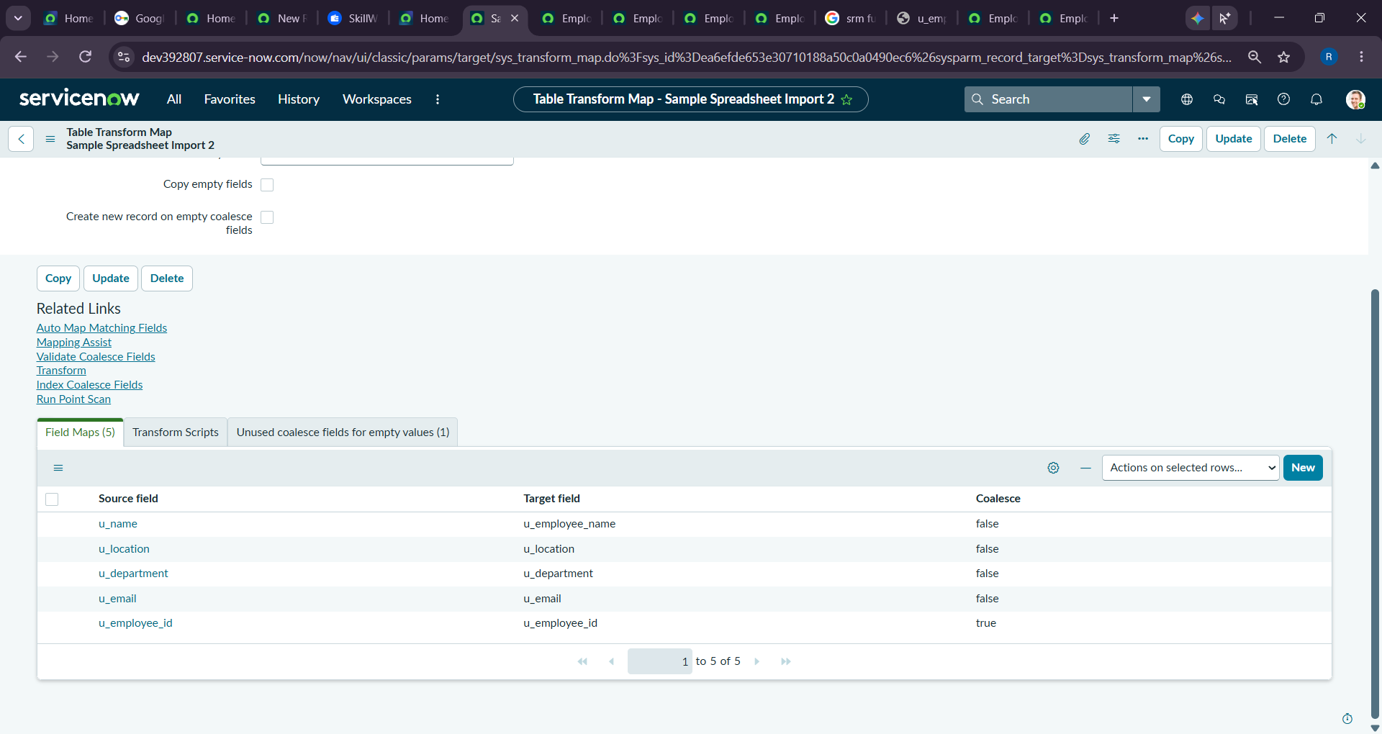
2. Sample Spreadsheet Import Transform Map.
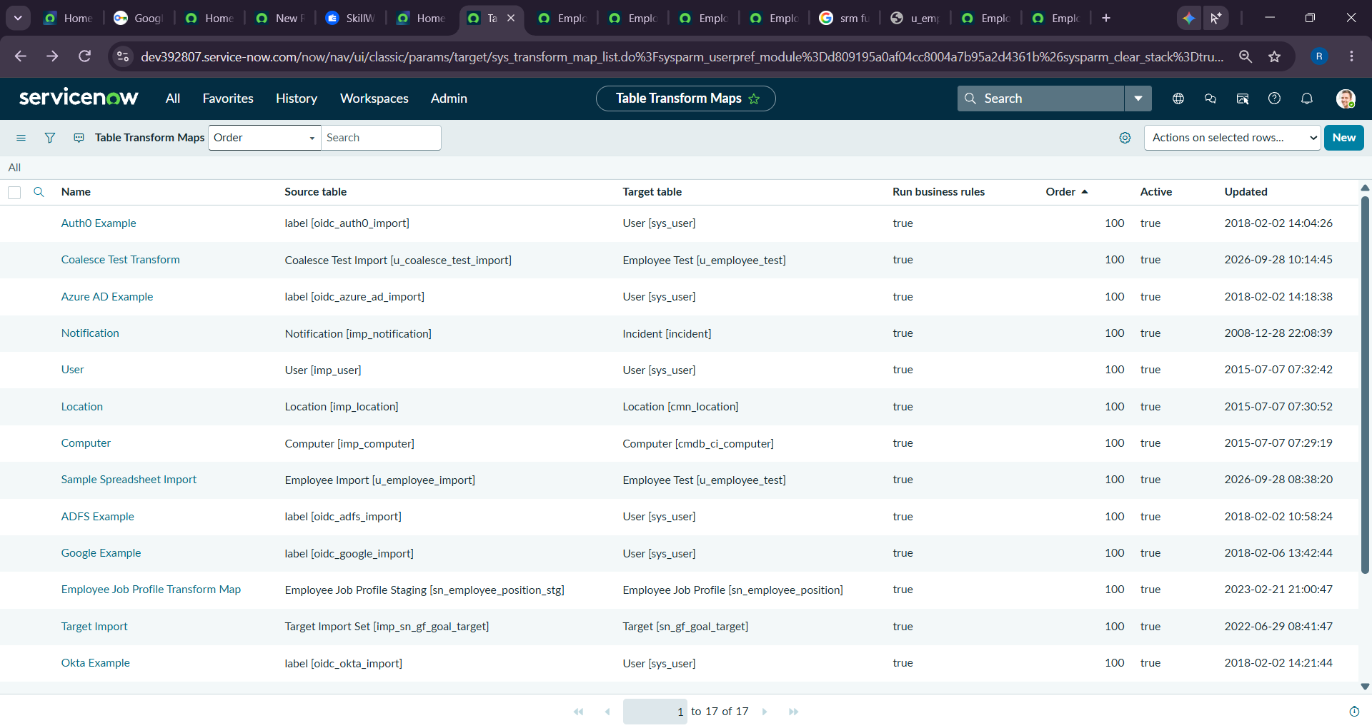
3. Employee ID field map with Coalesce enabled.
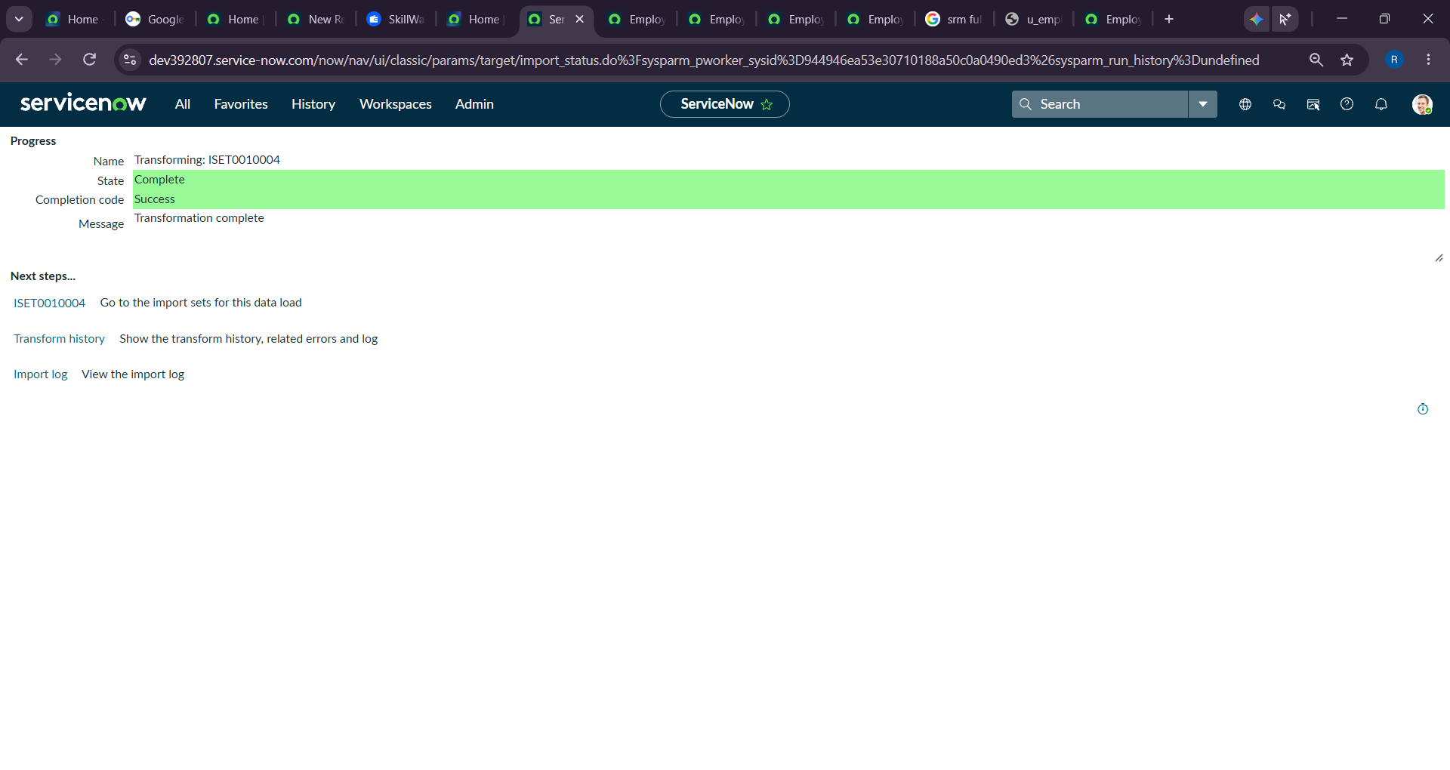
4. Transform History showing the first import results.
5. Employee Test table showing inserted/updated records.
6. Transform History for the repeated import.
7. Employee Analytics Dashboard with the completed reports.
